Mechanical Ejection System Design Ideas

**System 1: Primary Design**

Description:

A vertical dispenser tube filled with discs is centered over the metal sensing area, so that when the discs are dispensed, they land close to where the metal is detected. The tube has two holes in the bottom of the cylindrical face. One slot faces forwards to allow the discs to slide out of the tube; the second hole is directly behind and will allow the markers to be poked out from behind.

There will be a long skewer along the underside of the main body in the center. This skewer will be operated using a cam system to produce linear motion from circular motion. This skewer will poke out the disc markers from the dispenser tube. The skewer will be held in place by sections of a drinking straw.

The motor will be mounted at the rear, to reduce electronic noise in the coils at the front, with the motor facing down, connected to the main wheel.

Pros:

* Minimal electronic noise
* Marker dropped at the same end of the coil increases accuracy, power consumption and time elapsed during marking.
* No servo motor used, just a regular DC motor, creates power savings as the motor does not need to constantly be on.

Cons:

* It takes up space at both the front and the back.
* It’s fairly complicated and has multiple interacting moving parts that increase the likelihood of failure.
* The diameter of the tube and tokens have to be similar to a degree that the chips must be able to fall through the tube, but still able to be pushed out at the bottom.
* The tokens must be flat and smooth so that they can slide out without much friction generated.

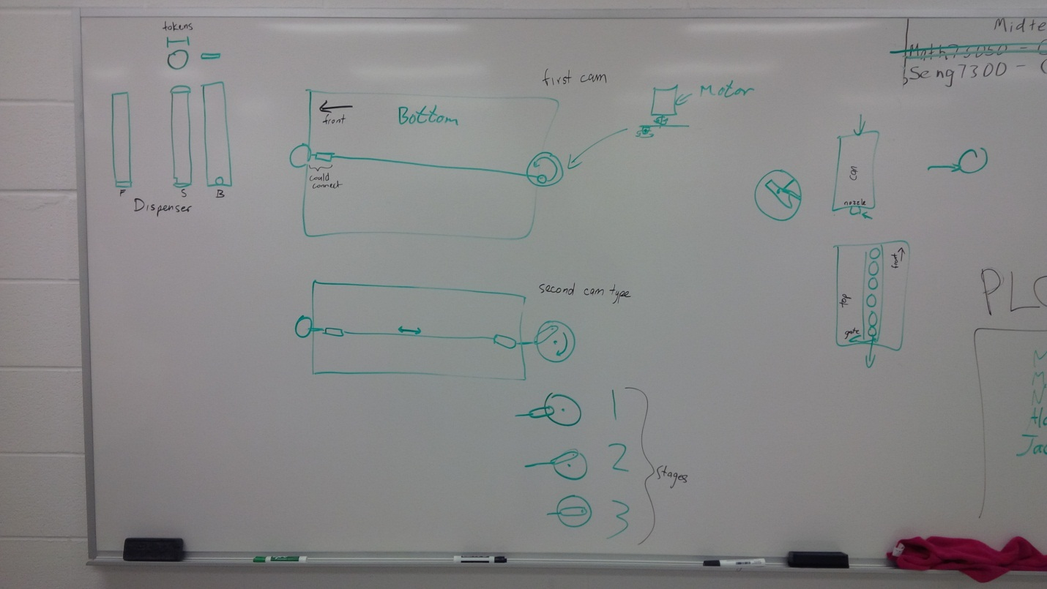

Figure 1. System 1

**System 2: Secondary Design A**

Description:

It would be similar to a dispenser from a video from MIT that used marbles. There would be a container that holds marbles, perhaps a paintball hopper, and a gate that would be powered by a motor that would open and close to let one marble out at a time.

Pros:

* Potentially fewer moving parts
* We potentially don’t have to build a container to hold the marbles.

Cons:

* Marbles are spherical in shape and would be likely to bounce and/or roll away from the spot to be marked.
* The motorized gate system could be much closer to the coils, increasing electronic noise in the readings from the coils.
* Timing becomes an issue with the gate, could make the overall system more complex.

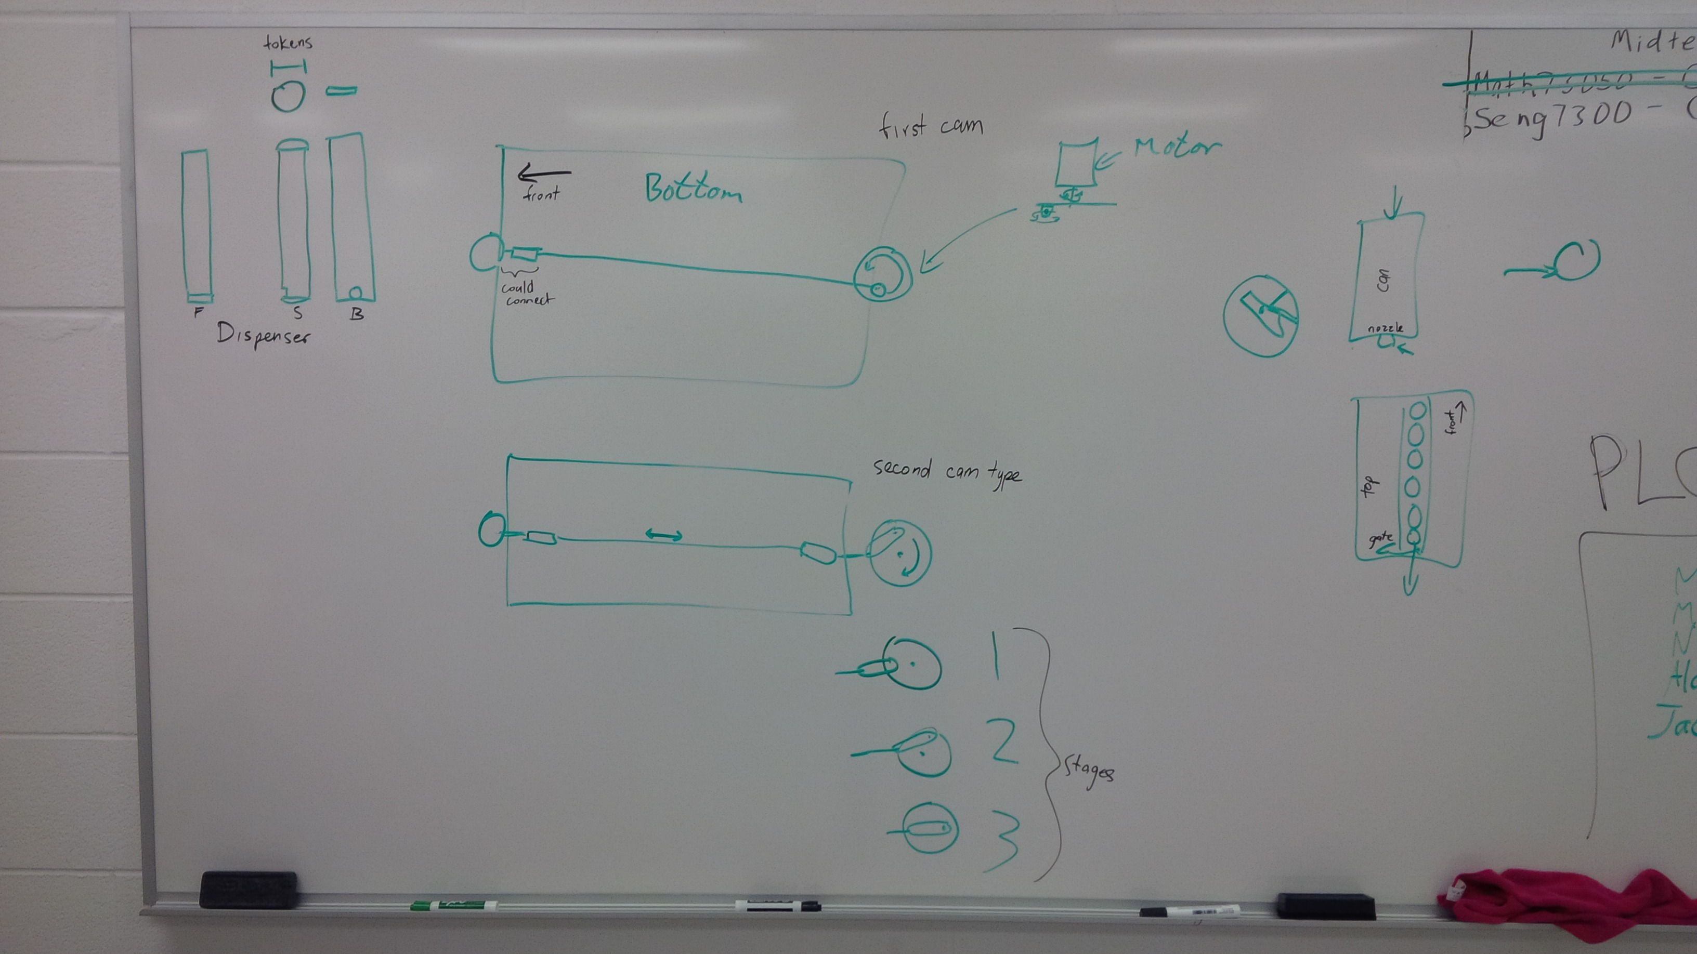

Figure 2. System 2

**System 3: Secondary Design B**

Description:

It would use a can of compressed gas/air that contains a material that could be used for marking.

Pros:

* The marking will be exactly where we aim it and it will not move or bounce or roll away.

Cons:

* Need quite a bit of force on the nozzle to release the contents of the can.
* The size of the can is unwieldy and would be awkward to mount to the chassis.
* It is messy and requires clean-up. “Could damage the Martian eco-system”



Figure 3. System 3